PROJECT MANAGEMENT
Workbook

2025
Student Name:
DUBYALA VEDA SAI
(2203A51472)

Project Description
Project Description
The Eco-Friendly Smart Home Development Project aims to create a neighborhood of homes that integrate cutting-edge technology with sustainable building practices. This initiative focuses on constructing residences that maximize convenience, minimize environmental impact, and promote cost savings for homeowners by incorporating smart home technology and eco-friendly features.
Project Objectives
- Energy Efficiency: Design homes to significantly reduce energy consumption through smart thermostats, automated lighting systems, and other energy-saving technologies.
- Water Conservation: Implement water-wise solutions, including smart irrigation systems and water-efficient fixtures, to minimize water usage.
- Sustainable Materials: Utilize environmentally responsible building materials, such as sustainably sourced wood and recycled content, while prioritizing locally sourced materials and minimizing the use of harmful chemicals.
- Waste Management: Minimize construction waste and facilitate efficient recycling and composting for residents.
- Renewable Energy: Integrate renewable energy sources, such as solar panels, to enable homes to generate their own clean electricity.
- Smart Home Integration: Connect all smart devices within the home to a central control system, allowing for seamless management of energy usage, security, and comfort.
- Environmental Preservation: Prioritize the preservation of natural surroundings by incorporating green spaces, planting trees, and creating habitats for local wildlife.

PART B
Initiating Process Group
Introduces you to two PMBOK Processes
- Create Charter
- Identify Stakeholders

Project Charter
Project Title |  | Eco-Friendly Smart Home Development
Organization |  | GREEN HOME DEVELOPMENTS
Start Date. |  | 2024-01-15
End Date. |  | 2026-12-31
Project. Champion |  | DUBYALA VEDA SAI
The Eco-Friendly Smart Home Development Project aims to create a neighborhood of homes that integrate cutting-edge technology with sustainable building practices. This initiative focuses on constructing residences that maximize convenience, minimize environmental impact, and promote cost savings for homeowners by incorporating smart home technology and eco-friendly features. The project will establish a community that prioritizes environmental responsibility, technological innovation, and resident well-being.

Justification:This project will meet the growing demand for sustainable and technologically advanced housing. It will reduce the environmental footprint of residential construction, lower utility costs for homeowners, promote healthier living environments, and create a desirable community that attracts environmentally conscious buyers.

High level Requirements |  | - Expertise in sustainable architecture and construction practices.  - Knowledge of smart home technologies and their integration.  - Adherence to green building certifications (e.g., LEED, Energy Star).  - Compliance with local environmental regulations and building codes.  - Community planning expertise to ensure a cohesive and sustainable neighborhood design.
Success Criteria& Who Measures it. |  | - Successful completion of homes according to sustainability and smart home specifications, measured by third-party certification agencies (e.g., LEED inspectors).  - Homeowner satisfaction with energy efficiency and smart home features, measured by post-occupancy surveys.  - Adherence to the project budget and timeline, measured by the Project Management Office and stakeholders.  - Positive environmental impact, measured by reductions in energy and water consumption compared to conventional housing developments, and ecological impact assessments.
Stakeholder List |  | D.VEDA SAI (Project Lead/Developer), Samantha "Sam" Lee (Environmental Council), Officer Michael Davis (Planning Department), Emily Patel (Prospective Homebuyer), Dr. Maya Singh (Sustainability Consultant), Ethan Hall (Smart Home Tech Integrator), Liam Reed (Lead Architect), Jack Harris (Contractor/Builder), Neighbors to the Development, Oakwood City Community, Utility and Service Providers, Local Media and Industry Observers
Project Budget |  | ₹1,957,500.
Assigned Project Manager, Responsibility and Authority Level |  | [ DUBYALA VEDA SAI] is the assigned project manager. They will report to [CEO RITESH KUMAR]. [DUBYALA VEDA SAI] has the authority to manage the project budget, resources, and schedule, and make decisions related to project execution, within the approved project scope.
Signatures |  | CEO & Head of operation  DUBYALA VEDA SAI RITESH KUMAR

Stakeholders
Stakeholder | Role
DUBYALA VEDA SAI | Project Lead/Developer
SAMANTHA | Environmental Council
Emily Patel | Prospective Homebuyer
Officer Michael Davis | Planning Department
CEO(RITESH KUMAR) | CEO
Neighbors to the Development
Dr. Maya Singh | Sustainability Consultant
Ethan Hall | Smart Home Tech Integrator
Liam Reed | Lead Architect
Jack Harris | Contractor/Builder
Oakwood City Community
Utility and Service Providers
Local Media and Industry Observers

How to Rank the Stakeholders?
In determining the rank of the stakeholders, use the following approach. Identify stakeholders that have substantial interest in the outcome of the project and have substantial power to help achieve the project goals.
- High Power and High Interest in Project Outcome: D.VEDA SAI, SAMANTHA, RITESH KUMAR
- High Power but Low Interest in Project Outcome: OFFICER MICHAEL DAVIS
- Low Power but High Interest in Project Outcome: EMILY PATEL, NEIGHBORS TPO DEVELOPMENT
- Low Power and Low Interest in Project Outcome: Dr. Maya Singh , Ethan Hall (Smart Home Tech Integrator)

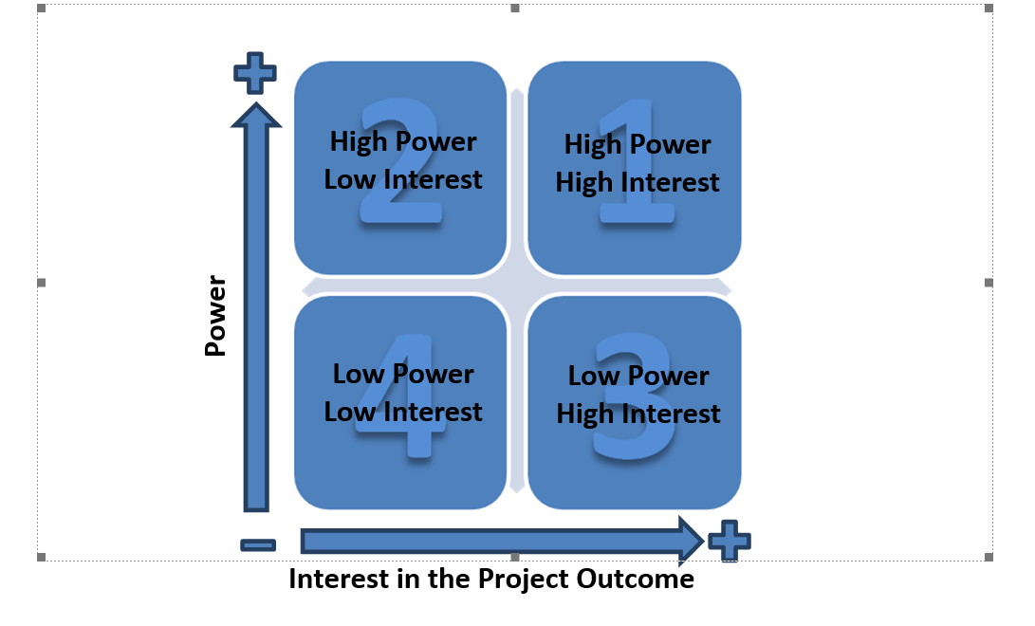

Stakeholders Register & Management Strategy

2.1 Stakeholder Register & Management Strategy
Stakeholder | Stakeholder Rank (High/Med/Low) | Role | Goal (Interest or Outcome for the Stakeholder) | Management Strategy
Ritesh Kumar (CEO) | High Power, High Interest | CEO of Development Company | Ensure project aligns with company strategy, financial success, and positive reputation. | Closely manage; keep informed; involve in key decisions; manage expectations; provide regular high-level updates.
DUBYALA VEDA SAI (Project Lead/Developer) | High Power, High Interest | Project Lead/Developer | Successful project delivery, adherence to specifications, budget, and schedule. | Closely manage; collaborate; provide clear direction and resources; facilitate problem-solving.
Samantha "Sam" Lee (Environmental Council) | High Power, High Interest | Representative of Environmental Council | Ensure the project meets environmental regulations, sustainability standards, and minimizes negative impact. | Closely manage; collaborate; involve in environmental decisions; provide regular updates on sustainability aspects; address concerns proactively.
Officer Michael Davis (Planning Department) | High Power, Medium Interest | Representative of Planning Department | Ensure the project complies with local regulations, zoning laws, and building codes. | Keep satisfied; provide necessary documentation and updates; ensure compliance; address regulatory concerns promptly.
Emily Patel (Prospective Homebuyer) | Medium Power, High Interest | Prospective Homebuyer | Desirable, high-quality, and sustainable homes that meet their needs and expectations. | Keep informed; involve in design feedback; provide clear communication about project progress and features; manage expectations.
Neighbors to the Development | Low Power, High Interest | Local Residents | Minimize disruption during construction; ensure the development is aesthetically pleasing and does not negatively impact their property values or quality of life. | Keep informed; address concerns; involve in community meetings; manage expectations; build positive relationships.
Dr. Maya Singh (Sustainability Consultant) | Medium Power, Medium Interest | Sustainability Consultant | Ensure the project incorporates best practices in sustainability and achieves its environmental goals. | Keep informed; consult for expertise; involve in relevant decisions related to sustainability; value their input.
Ethan Hall (Smart Home Tech Integrator) | Medium Power, Medium Interest | Smart Home Tech Integrator | Successful integration of smart home technologies according to specifications and within budget. | Keep informed; collaborate on technical requirements; coordinate integration activities.
Liam Reed (Lead Architect) | Medium Power, Medium Interest | Lead Architect | Successful design and execution of the architectural plans, meeting aesthetic, functional, and sustainability goals. | Keep informed; collaborate on design; ensure clear communication and alignment with project goals.
Jack Harris (Contractor/Builder) | Medium Power, Low Interest | Contractor/Builder | Complete construction on time, within budget, and according to specifications. | Keep satisfied; provide clear specifications and requirements; monitor progress; address construction-related issues.
Oakwood City Community | Low Power, Low Interest | General Public/Community | Positive impact on the community; enhancement of local amenities; economic benefits. | Monitor; provide information on project benefits; address potential concerns; maintain positive public relations.
Utility and Service Providers | Low Power, Low Interest | Providers of essential services (electricity, water, etc.) | Timely connection of services; coordination of infrastructure requirements. | Monitor; coordinate service connections; provide necessary information and access.
Local Media and Industry Observers | Low Power, Low Interest | Media, Industry Analysts | Project awareness, industry trends, and public perception. | Monitor; provide periodic updates; manage public relations.

Planning Process Group
Collect Requirements Process
Requirement Document

Planning Process Group
Category | Requirement | Stakeholder | Acceptance Criteria
Project Scope | Defined scope of work for eco-friendly home construction, including number of homes, community amenities, and sustainability features. | Ritesh Kumar (CEO), Alex Chen (Project Lead/Developer), Liam Reed (Lead Architect) | Scope document approved by CEO and key stakeholders; alignment with market research and feasibility study.
Sustainability Plan | Detailed plan for achieving sustainability goals, including materials selection, energy efficiency targets, water conservation measures, and waste management. | Samantha "Sam" Lee (Environmental Council), Dr. Maya Singh (Sustainability Consultant) | Approval from Environmental Council; compliance with green building certifications (e.g., LEED); achievement of specific environmental targets.
Regulatory Compliance | Plan for obtaining all necessary permits and approvals from local authorities, including zoning, building codes, and environmental regulations. | Officer Michael Davis (Planning Department) | All required permits and approvals secured; compliance with relevant regulations.
Budget | Detailed project budget, including costs for land acquisition, construction, materials, labor, technology integration, and marketing. | Ritesh Kumar (CEO), Alex Chen (Project Lead/Developer) | Budget approved by CEO and investors; adherence to cost estimates; financial feasibility analysis.
Schedule | Project schedule with key milestones, timelines for each phase (design, construction, marketing, sales), and dependencies. | DUBYALA VEDA SAI (Project Lead/Developer), Jack Harris (Contractor/Builder) | Project schedule approved by key stakeholders; realistic timelines; critical path analysis.
Stakeholder Engagement | Plan for communicating with and involving stakeholders throughout the project lifecycle, including homebuyers, community members, and regulatory bodies. | DUBYALA VEDA SAI (Project Lead/Developer), Emily Patel (Prospective Homebuyer), Neighbors to the Development | Stakeholder engagement plan approved; regular communication and feedback mechanisms established; positive relationships with stakeholders.
Technology Integration | Plan for integrating smart home technologies, including selection of systems, compatibility, installation, and testing. | Ethan Hall (Smart Home Tech Integrator), Alex Chen (Project Lead/Developer) | Technology integration plan approved; systems selected and tested; seamless functionality.
Risk Management | Identification and assessment of potential risks, and development of | DUBYALA VEDA SAI (Project Lead/Developer) | Risk management plan approved, key risks .

PROJECT OBJECTIVE
To create a neighborhood of homes that integrate cutting-edge technology with sustainable building practices.

DELIVERABLES
Construction of eco-friendly smart homes, including energy-efficient systems, water conservation features, and use of sustainable materials.
Homes are constructed according to specifications, meet sustainability standards, and incorporate the agreed-upon smart home technology.

TECHNICAL REQUIREMENTS
  - Sustainable building materials,
  - smart home technology systems,
  - energy-efficient appliances,
  - water-saving fixtures
  - renewable energy integration.
LIMITS AND EXCLUSIONS (Constraints)
- Budget limitations, timeline constraints, regulatory restrictions, and availability of sustainable materials.
- Limits and exclusions are clearly defined, communicated to all stakeholders, and managed within the project plan.
RISKS
- Potential delays due to weather, material shortages, or regulatory approvals; cost overruns; and challenges in technology integration.
- Safety risks during on-site construction
- Key risks are identified, assessed, and mitigation strategies are developed and implemented.
ACCEPTANCE CRITERIA
Homes meet sustainability certifications (e.g., LEED), homeowner satisfaction with smart home features, and compliance with building codes and regulations.

Signatures

RITESH KUMAR DUBYALA VEDA SAI

Project Scope Statement

2.5. WORK BREAK DOWN STRUCTURE
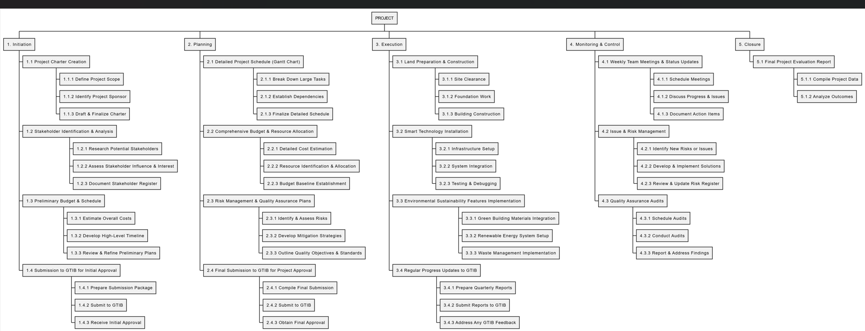

Define and Estimate Activities and Resources
Activity List

Activity Durations
Activities | Effort | Resource
Site Preparation and Landscaping | Medium | Landscapers, heavy equipment operators, surveyors
Foundation Construction | High | Construction workers, concrete specialists, structural engineers
Home Framing and Structure | High | Carpenters, structural engineers, construction supervisors
Installation of Energy-Efficient Systems | Medium-High | HVAC technicians, electricians, solar panel installers
Installation of Water Conservation Features | Medium | Plumbers, irrigation specialists
Smart Home Technology Integration | Medium | Smart home technicians, electricians, network engineers
Interior Finishing | High | Carpenters, painters, flooring installers, interior designers
Exterior Finishing | Medium | Painters, siding installers, roofers

2.6.Activity Durations
Activity Durations

Activity | Duration (days)
Gathering Sustainable Labour & Materials | 7
Foundation Laying with Eco-Friendly Concrete | 25
Smart Energy Systems Installation (Solar, Batteries) | 12
Green Roofing & Insulation Works | 10
Smart Home Automation Setup (IoT Systems) | 8
Eco-Friendly Interior & Fixtures Fit-out | 18
Water Harvesting & Greywater Recycling Systems | 7

Deliverables List by Team
Team | Activities
Team 1 | Site Surveys & Smart Structural Audits, Reinforced Green Foundations
Team 2 | Installed Ramps, Smart Doors, Accessible Eco-Toilets, Fire Safety Systems
Team 3 | Flexible Smart Living Spaces, Home Automation Labs
Team 4 | Rainwater Harvesting Systems, Solar PV & Smart LED Installations

Plan Risk Management
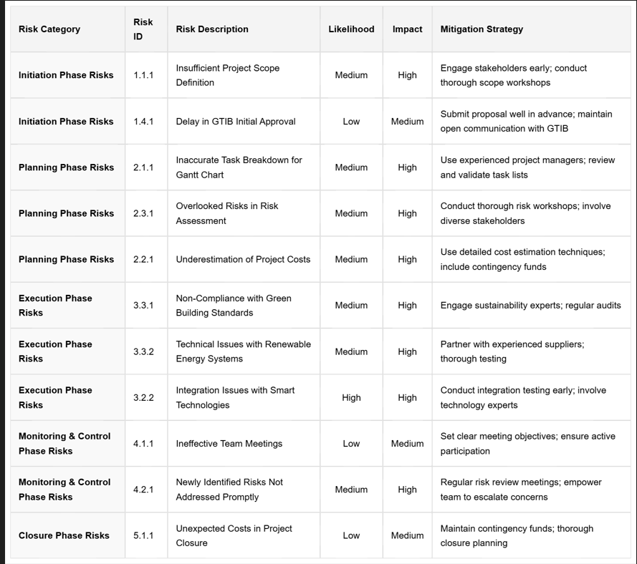

RISK MATRIX:
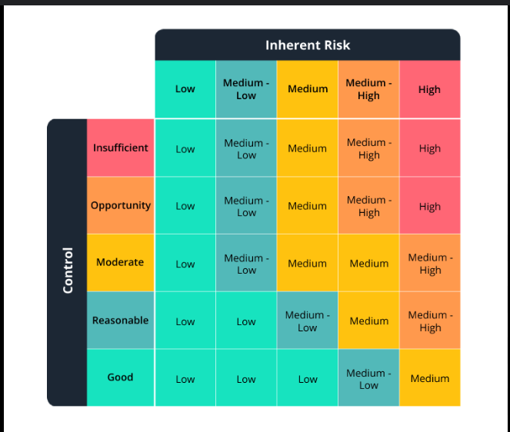

Plan Quality Management

Plan Quality

Quality Roles and Responsibilities

Quality Roles and Responsibilities: Eco-Friendly Smart Home Development Project
Role | Responsibility
Operation and Project Manager | To supervise and ensure all smart home development activities comply with eco-construction standards, sustainability goals, safety, and timelines.
Civil Engineer | To ensure design accuracy, structural sustainability, green material integration, and adherence to eco-friendly regulations and approved plans.
Vendor Manager | To verify that all eco-friendly construction materials (e.g., recycled cement, sustainable steel, green-certified tiles) meet quality and environmental specifications.
Site Inspector | To conduct regular inspections of the smart home premises for green building compliance, quality control, and sustainability verification.
Government Quality Officer | To audit the project periodically to ensure compliance with public green construction standards and smart housing facility guidelines.

Quality Management Plan
Summarizes the previous Section
Quality Management Plan

Quality Management Plan
Project Title: Eco-Friendly Smart Home Development Project

Overview
To ensure that eco-friendly smart homes meet top standards for sustainability, energy efficiency, safety, and smart technology integration, all project deliverables — from renewable energy installations to smart home automation systems — will undergo formal quality review, environmental testing, and performance verification prior to acceptance.

Quality Responsibilities and Quality Roles
Quality is monitored by the Project Manager and Vendor Manager specialized in green building practices. These responsibilities are managed by a designated Sustainability Officer and a Smart Systems Coordinator.

Quality Assurance Approach
We assure quality by integrating sustainable materials, adhering to green building standards (e.g., LEED, EDGE), and regularly auditing smart technologies and energy-saving systems.

Quality Control Approach
Each vendor and subcontractor is required to meet eco-certification standards. Products and services (e.g., solar panels, smart thermostats, eco-friendly insulation) are inspected more frequently to ensure compliance with environmental and performance benchmarks.
Quality Reporting Plan: Daily quality checks are performed across all batches of green building materials and smart system installations, with results documented in an eco-compliance report to support continuous improvement.

Develop Human Resources Plan
Human Resources Plan

Human Resources Plan
Project Title: Eco-Friendly Smart Home Development Project
Date: April 2025

Roles and Responsibilities
Project Manager:
Leads project planning, resource management, sustainability oversight, and stakeholder communication focused on green building principles.
Green Quality Engineer:
Conducts eco-inspections, ensures compliance with sustainable construction standards, and addresses non-conformance issues.
Sustainable Structural Engineers & Surveyors:
Carry out site evaluations, green structural design audits, and eco-friendly reinforcement detailing.
Civil, MEP & Smart Systems Supervisors:
Manage installation of eco-plumbing, energy-efficient electrical systems, smart automation, and sustainable infrastructure.
Eco-Carpenters & Fit-Out Specialists:
Install modular partitions, acoustic insulation from renewable materials, and smart energy-efficient fixtures.

Staff Acquisition
Green Hiring Initiative:
Prioritize hiring locally based eco-trained masons, electricians, carpenters, and smart home technicians through vetted green-certified contractors to enhance community involvement and sustainable practices.

Staff Release
Phased Offboarding:
Team members are formally offboarded upon completion of green building milestones (e.g., solar panel installation, smart system setup) with documented handover and sustainability impact reporting.

Training
Eco Induction Workshop:
All project staff attend a two-day onboarding focused on green building methods, smart home technologies, safety practices, energy conservation, and waste reduction.
Quality & Sustainability Refreshers:
Monthly workshops covering green compliance checklists, handling of non-conformance, emergency eco-protocols, and updates on the latest smart tech solutions.
Performance Reviews:
Project performance and sustainability compliance are reviewed by the Project Manager with continuous improvements driven by eco-efficiency goals.

Regulation and Policy Compliance
All personnel must comply with government labor laws, environmental building codes, safety regulations (e.g., eco-PPE, smart scaffolding systems), and the project’s Eco Code of Conduct. Contractors must hold current green certifications, insurances, and uphold sustainability commitments throughout the project lifecycle.

Item description
Item Category | Details
Eco-Friendly Machinery | Solar panel installers, electric concrete mixers, and low-emission construction vehicles
Smart Home Tools | Smart meters, energy-efficient lighting tools, smart thermostats, and safety gear (eco-friendly helmets, biodegradable gloves, recyclable goggles)
Green Lifting Equipment | Electric tower cranes, solar-powered mobile cranes, and eco gantry cranes
Sustainable Earthmoving Equip. | Electric loaders, hybrid bulldozers, and low-emission dump trucks
Smart MEP Equipment | Energy-efficient HVAC units, smart plumbing testers, solar water heating systems, and advanced home automation devices

Note:
- All machinery and equipment must be operated by certified personnel and maintained according to manufacturer guidelines.
- Tools and PPE should be checked daily for functionality and safety compliance.

Communication Management Plan
Communication Management Plan
Stakeholder | Communication Needs | Frequency | Method | Responsibility
DUBYALA VEDA SAI (Project Lead/Developer) | Project progress, budget status, risk updates, key decisions | Daily/Weekly | Meetings, email, project management software | Project Manager
Emily Patel (Prospective Homebuyer) | Project updates, design choices, pricing, construction timeline, handover process | Bi-weekly/Monthly | Email, website, presentations, site visits | Sales/Marketing Team, Project Manager
Samantha "Sam" Lee (Oakwood City Environmental Council) | Compliance reports, environmental impact assessments, sustainability initiatives | Monthly/Quarterly | Formal reports, meetings, presentations | Sustainability Consultant, Project Manager
Officer Michael Davis (Oakwood City Planning Department) | Permits, approvals, adherence to regulations, community impact | As needed | Formal letters, meetings, site visits | Project Manager, Legal Team
Dr. Maya Singh (Sustainability Consultant) | Integration of sustainable features, progress on environmental goals | Weekly/Monthly | Meetings, reports, email | Project Manager, Sustainability Consultant
Ethan Hall (Smart Home Tech Integrator) | Technical specifications, integration schedules, testing results | Weekly | Meetings, email, project management software | Project Manager, Smart Home Tech Integrator
Liam Reed (Lead Architect) | Design updates, approvals, changes, construction progress | Weekly | Meetings, design documents, site visits | Project Manager, Lead Architect
Jack Harris (Contractor/Builder) | Construction plans, schedules, materials, site progress, issues | Daily/Weekly | Meetings, site meetings, project management software | Project Manager, Contractor/Builder
Neighbors to the Development | Construction schedule, noise mitigation, traffic management, project updates | Bi-weekly | Community meetings, newsletters, website | Community Liaison, Project Manager
Oakwood City Community | Project benefits, economic impact, environmental contributions | Quarterly | Public meetings, press releases, website | Project Manager, Marketing Team
Utility and Service Providers | Connection requirements, schedules, service agreements | As needed | Meetings, email, formal requests | Project Manager, Contractor/Builder
Local Media and Industry Observers | Project milestones, innovative features, success stories | As needed | Press releases, site visits, interviews | Marketing Team, Project Manager

Cost Estimation
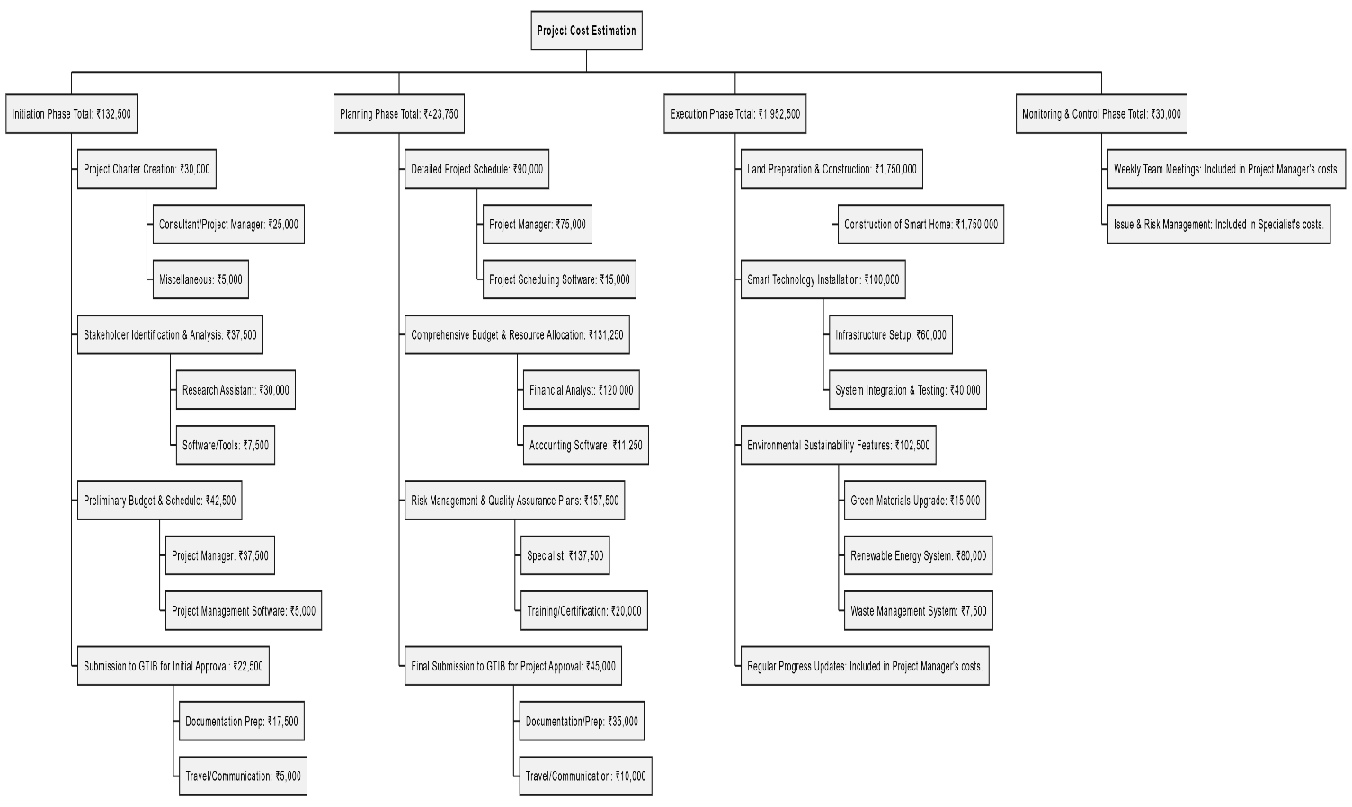

Project Summary
Now that we have completed the project plan you can summarize the details such as:

Performance Indicator | Planned
Total Effort | 18,936 Hr
Total Duration | 1070 days
Start Date | 15-01-2024
End Date | 31-12-2026
Cost | ₹1,957,500.

Risk Monitoring and Control
Updated Risk Register

Risk ID | Risk | Risk Response | Resource Responsible for Mitigation | Current Risk Status
1 | Cost Overruns | Use fixed-price contracts with key suppliers; establish a contingency fund; implement rigorous cost control measures. | DUBYALA VEDA SAI (ProjectLead/Developer), Ritesh Kumar (CEO) | To be determined (TBD) – Will depend on ongoing cost tracking.
2 | Project Delays | Develop a detailed project schedule with buffers; closely monitor critical path activities; secure backup suppliers for key materials; implement a fast-tracking or crashing strategy if necessary. | Jack Harris (Contractor/Builder), Alex Chen (Project Lead/Developer) | TBD – Will depend on ongoing schedule tracking.
3 | Negative Environmental Impact | Adhere to strict environmental regulations; implement best practices for erosion control, waste management, and pollution prevention; conduct regular environmental audits; obtain necessary environmental certifications. | Samantha “Sam” Lee (Environmental Council), Dr. Maya Singh (Sustainability Consultant) | TBD – Will depend on ongoing monitoring and audits.
4 | Homebuyer Dissatisfaction | Conduct thorough market research; involve prospective homebuyers in the design process; provide clear and consistent communication; address concerns and feedback promptly; ensure high-quality construction and finishing. | Emily Patel (Prospective Homebuyer), Alex Chen (Project Lead/Developer) | TBD – Will depend on ongoing feedback and satisfaction surveys.
5 | Technology Integration Issues | Select reliable and compatible smart home technologies; conduct thorough testing and quality assurance; provide training and support for installers and homeowners. | Ethan Hall (Smart Home Tech Integrator), Alex Chen (Project Lead/Developer) | TBD – Will depend on testing and integration phases.
6 | Regulatory Changes/Approvals | Closely monitor changes in regulations; maintain open communication with relevant authorities; ensure all designs and plans are compliant; engage legal counsel as needed. | Officer Michael Davis (Planning Department), Alex Chen (Project Lead/Developer) | TBD – Will depend on ongoing monitoring.
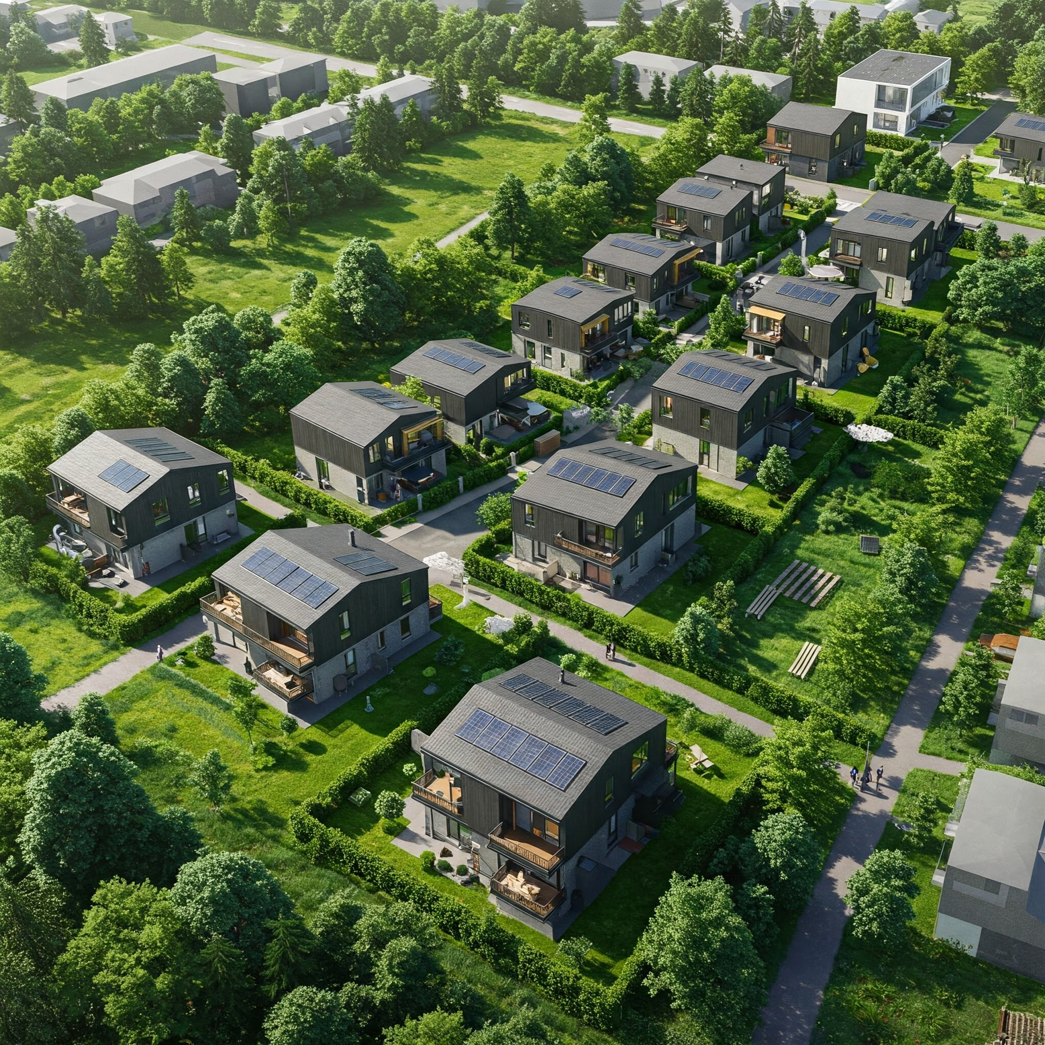

***
INTRODUCING YOU
“THE ECO FRIENDLY SMART HOMES “
“A REVOLUTION IN THE CONSTRUCTION WORLD”

2.15 Project Change Control
Project Change Control is a formal process used to manage and track changes in the Eco-Friendly Smart Home Development Project. It ensures that any proposed changes are properly evaluated for their impact on the project's scope, schedule, and budget. This process will involve submitting a change request, conducting an impact assessment, and obtaining approval (or rejection) from the designated authority. Approved changes will be implemented, and all changes will be documented to maintain transparency and control throughout the project's lifecycle. This process will help prevent scope creep, manage evolving requirements, and ensure the project remains aligned with its objectives of delivering high-quality, sustainable, and technologically advanced homes.

2.16 Lessons Learned

Phase | What Worked? | What Did Not Work? | Lessons for Next Project
Initiation Phase | Early engagement with the city planning department and environmental council. | Delays in securing all necessary permits and approvals. | Secure all necessary permits and approvals before the project kickoff.
Planning Phase | Detailed architectural designs incorporating sustainable features and smart home technology specifications. | Underestimated the complexity of integrating diverse smart home systems. | Allocate sufficient time and resources for thorough testing and integration of smart home technologies.
Execution Phase | Use of sustainable building materials and construction techniques. | Supply chain disruptions for specific eco-friendly materials. | Prequalify multiple suppliers of sustainable materials and establish contingency plans for potential disruptions.
Monitoring and Controlling Phase | Regular meetings with stakeholders to track progress and address concerns. | Inconsistent communication of changes to homebuyers. | Implement a robust communication plan for change management, especially with homebuyers.
Closure Phase | Formal handover process with checklists for completed homes and documentation. | Delays in providing homeowners with comprehensive training on smart home systems. | Schedule and conduct thorough training sessions for homeowners on smart home systems well before the final handover.

"Where sustainable living meets intelligent design, crafting homes that nurture both our well-being and our planet."

